National Partnership for
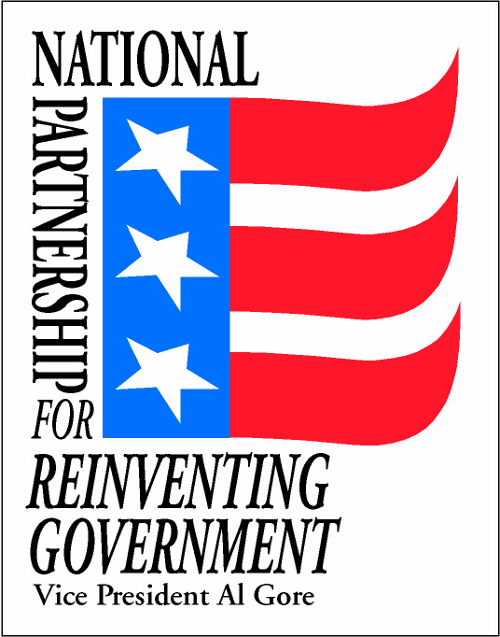


Reinventing Government

Suite 200
750 Seventeenth Street N.W.
Washington, D.C. 20006
Voice: 202-632-0150
Fax: 202-632-0390

For Immediate Release Contact: Kelly Paisley
Friday, March 3, 2000 (202) 694-0051

Washington, DC -- A unique network of community leaders from across the nation met today to share strategies and techniques for reducing gun violence. Over 30 representatives from the ten SafeCities came together to identify cooperative actions to reduce gun violence. During this first face-to-face meeting of representatives of the SafeCities Network, a new Internet website, www.safecities.gov, was unveiled. This site will give communities access to current information and data on gun violence reduction.

The SafeCities Network was established by Vice President Gore’s National Partnership for Reinventing Government specifically to help cities reduce gun violence. Under the initiative, ten communities from across the country formed a network for sharing successful strategies, working with federal law enforcement and other agencies, and gaining access to experts in gun violence reduction.

Louis F. Quijas, Chief of Police of High Point, North Carolina, addressed the group and described how his community worked together to dramatically reduce gun violence. “Reducing gun violence must be community-driven,” Chief Quijas said. “It is not just an issue for police. Like the groups represented by the SafeCities, we must engage all of our community - - law enforcement, faith and business leaders, educators, parents and other citizens. We are all in this together. ”

“It's important to recognize that communities have come together to reduce gun violence. The members of the SafeCities Network are dedicated to understanding and sharing what works to stop the violence and make our communities safer,” said Morley Winograd, Director of Vice President Gore's National Partnership for Reinventing Government.

The SafeCities Network is being supported by: the Department of Justice and its Office of Community Oriented Policing Services, the Executive Office of the US Attorneys, the Office of Justice Programs; the Department of the Treasury and its Bureau of Alcohol, Tobacco, and Firearms; the Office of National Drug Control Policy; Vice President Gore's National Partnership for Reinventing Government; and the Office of Management and Budget. Several private sector partners are also involved.

The SafeCities Network includes the following communities:

- Atlantic City Weed and Seed, Atlantic City, New Jersey
- Centinela Valley Juvenile Diversion Project, Inglewood, California
- City of Springfield's Violence Prevention Task Force, Springfield, Massachusetts
- Eastern District of Michigan Weed and Seed Sites (Detroit, Flint, Highland Park, and Inkster, Michigan)
- King County Violent Firearms Crime Coalition, Western District, Seattle, Washington
- Mayor's Task Force to End Gun Violence, Louisville, Kentucky
- Miami Police Department, Miami, Florida
- Safe City USA, Fort Worth, Texas
- SafeCities Alliance, Fort Wayne, Indiana
- Violence Prevention Coalition of Greater Los Angeles, California

###

